**User’s Guide and Test Plan**

*CMSC 495 Final*

*By: Shelley Schoppert, Jake Gonzalez, Justin Smith, Timothy Strickland*

*University of Maryland, Global Campus*

*Revision 1.3*

*10/11/2022*

Contents

**1. Introduction** 5

**2. Test Environment** 5

**2.1 Hardware** 5

**2.2 Software** 6

**2.3 Tools** 7

**2.4 Data** 7

**3. Diagrams** 7

**4. Test Specifications** 8

**4.1 User Interface test cases** 8

**4.1.1 Select Choose File Button** 8

**4.1.2 Select Submit button** 9

**4.1.3 Select Export** 11

**4.1.4 Return from Results page** 13

**4.1.5 About Button** 13

**4.1.6 Return from About page** 14

**4.2 File Handling** 14

**4.2.1 Incorrect file type is presented** 14

**4.2.2 User fails to upload an image before submitting** 15

**5. User’s Guide** 17

**5.1 Home Page** 17

**5.2 Results Page** 19

**5.3 About Page** 22

Figure 1: Flow Diagram 7

Figure 2: Exif Data 10

Figure 3: Exported Exif data 12

Figure 4 Home Page 17

Figure 5 Choose File Button 18

Figure 6 Explorer 18

Figure 7 Submit Button 19

- Figure 8 Data Pane 20

- Figure 9 Data Pane 2 21

- Figure 10 About Button 22

- Figure 11 About Page 22

**History of Changes**

|  |  |  |
| --- | --- | --- |
| **Initials** | **Comment** | **Rev** |
| TWS | Initial Submission | 1.0 |
| TWS | Update 1 rework | 1.1 |
| TWS | Removed references to PNG | 1.2 |
| TWS | Final Updates | 1.3 |
|  |  |  |
|  |  |  |
|  |  |  |

Table : History of Changes

# **1. Introduction**

**1.1 Objectives**

The purpose of this document is to outline the framework of testing strategies for our application.

**1.2 Background**

The idea is to create a program that uploads, analyzes and manipulates image metadata. The program will be able to handle both JPG and JPEG formats and produce EXIF data. Errors will be handled gracefully if encountered.

**1.3 Scope**

This document will not include specific test cases. Instead, it will highlight high level abstract tests that can be designed more specifically as the project progresses.

# **2. Test Environment**

## **2.1 Hardware**

A desktop or laptop computer capable of running the software is all that is required for testing hardware. The web application should be able to run in any modern web browser and requires no special hardware to test. The minimum specifications required for the computer(s) is:

• Core Duo processor or above;

• 4 GB RAM or more.

• 500GB hard disk drive (HDD) or solid-state drive (SDD);

• Mouse (wired or wireless);

• Keyboard (wired or wireless);

• Display at 1280 x 1024 for minimum viewing of images. The higher the resolution the better the image quality.

## **2.2 Software**

The following software is required for operation of the program. The ImageMetrics program (to be designed). Browser software. The following applications are required for the ImageMetrics program to work:

* Python3
  + Pillow Library installed using PIP
  + Python Flask using PIP
  + NumPy
  + Matplotlib
* HTML/CSS
  + **Landing/Home page**
    - **Upload Image** window – Contains buttons to be used on images.
    - **Choose File** button - opens Finder or File Explorer for users to choose their image
    - Once chosen, the **type** of photo will be displayed.
    - **Submit** button - submits photo to be analyzed and opens up the **Results** page.
    - Link to **About** page in upper right corner and bottom center of page.
    - Link to **Home** page in upper right corner and bottom center of page.
  + **Results page**
    - Will display photo analysis results (See section 4 - Test Specifications)
    - Results will be organized in a table or list format
    - Link to **About** page in upper right corner and bottom center of page.
    - Link to **Home** page in upper right corner and bottom center of page.
    - **Export** button - option to export file of the analysis report in **CSV** format.
  + **About page**
    - Describes what the application is used for
    - Contains guide on how to use website to analyze a photo
    - Lists the categories of information that will be obtained from the analysis

## **2.3 Tools**

Image editing software might be helpful but not required.

## **2.4 Data**

Images raw, modified images. JPEG and JPG are supported. CSV exported files.

# **3. Diagrams**

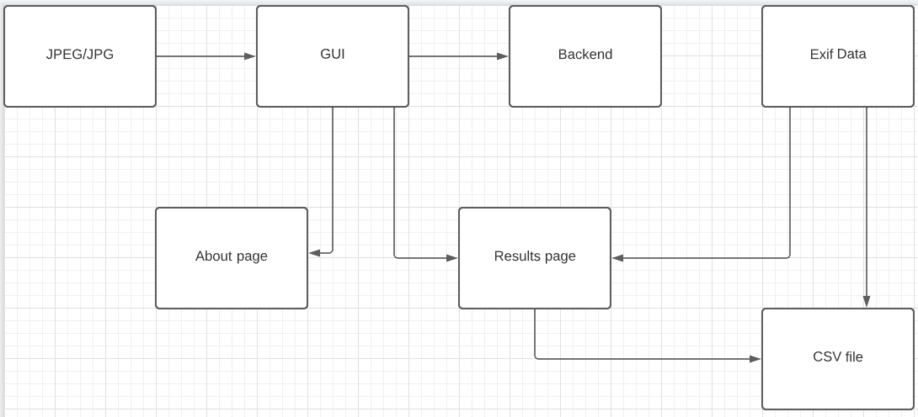

Figure : Flow Diagram

# **4. Test Specifications**

## **4.1 User Interface test cases**

These cases are for the testing of the program

### **4.1.1 Select Choose File Button**

**Objective**

The purpose of this test is to verify that the “Choose File” button allows the user to select an image.

**Input specifications**

1. Upload a photo or image to the GUI. This is done by clicking on the “Upload Button”.

**Output specifications**

1. Opens an explorer window that allows the user to select an image.
2. Once image has been selected, the image type is displayed next to the “Choose File” button.

### **4.1.2 Select Submit button**

**Objective**

The purpose of this test is to upload the image to the GUI.

**Input Specifications**

1. Select the “Submit” button once an image type is displayed next to the “Choose File” button.

**Output Specifications**

1. Exif data is printed to the screen as seen in the following image (next page):

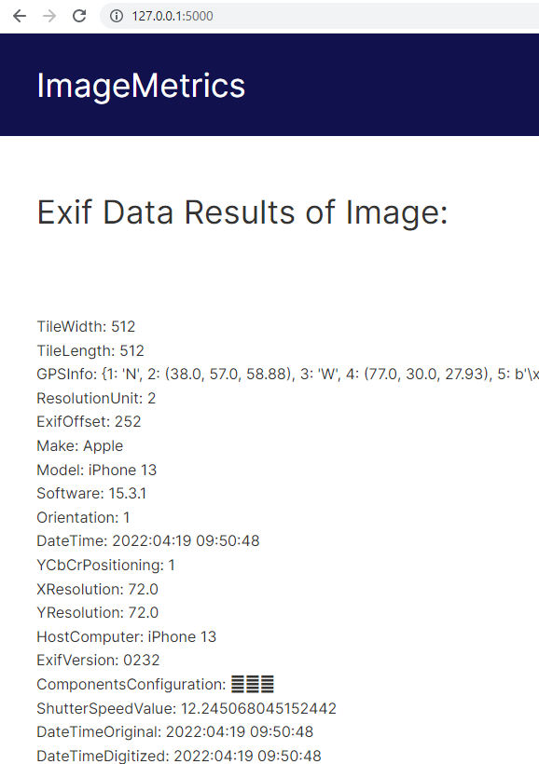

Figure : Exif Data

### **4.1.3 Select Export**

**Objective**

The purpose of this test is to export data to a file.

**Input Specifications**

1. Push the Export button.

**Output Specifications**

1. File is created with the exif data inserted.

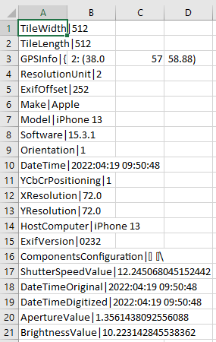

Figure : Exported Exif data

### **4.1.4 Return from Results page**

**Objective**

The purpose of this test is to return to the home page from the Results page.

**Input Specifications**

1. Once on the Results page, click the home button.

**Output Specifications**

1. Returns the user to the home page from the Results page.

### **4.1.5 About Button**

**Objective**

The purpose of this test is to present the “About” page to the user.

**Input Specifications**

1. Push the “About” button from the home page.

**Output Specifications**

1. User is presented the “About” page with details.

### **4.1.6 Return from About page**

**Objective**

The purpose of this test is to return to the home page from the About page.

**Input Specifications**

1. Once on the About page, click the home button.

**Output Specifications**

1. Returns the user to the home page from the About page.

## **4.2 File Handling**

### **4.2.1 Incorrect file type is presented**

**Objective**

The purpose of this test is to ensure incorrect file types are handled appropriately.

**Input Specifications**

1. Attempt to upload a file that is not jpg or jpeg.

**Output Specifications**

1. The file is rejected and a helpful message is displayed.

### **4.2.2 User fails to upload an image before submitting**

**Objective**

The purpose of this test is to ensure a proper error is displayed if the user forgets to upload an image via the “Choose File” button on the home page and then clicks Submit.

**Input Specifications**

1. No file selected.

**Output Specifications**

1. The message “Please select a file” is displayed.

|  |  |  |
| --- | --- | --- |
| **Test Case** | **Pass/Fail** | **Comments** |
| 4.1.1 | Pass |  |
| 4.1.2 | Pass |  |
| 4.1.3 | Pass |  |
| 4.1.4 | Pass |  |
| 4.1.5 | Pass |  |
| 4.1.6 | Pass |  |
| 4.2.1 | Pass |  |
| 4.2.2 | Pass |  |

# **5. User’s Guide**

The User’s Guide will explain how to navigate through the GUI in order to upload an image and download the Exif Data.

### **5.1 Home Page**

Figure Home Page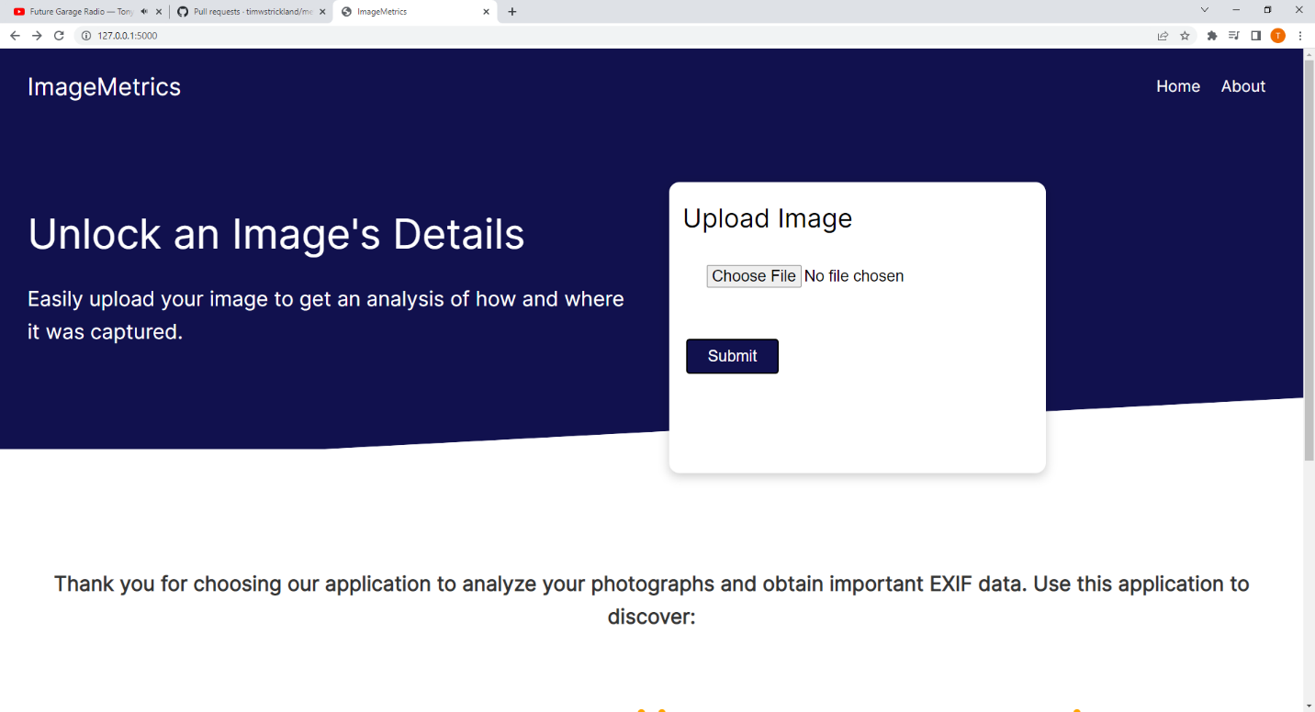

Figure Choose File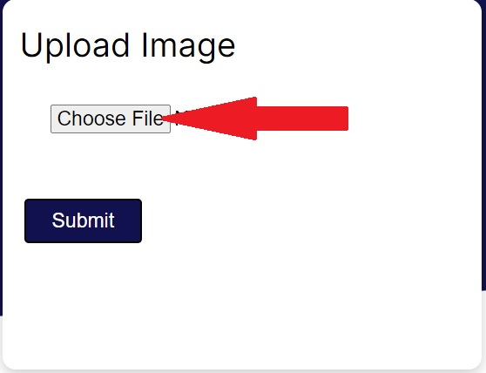 Button

* Choose File button
  + Users can add an image to retrieve exif data. Takes the user to the results page. Image must be jpg or jpeg.
    - Opens a navigation window so the user can navigate to the file in question

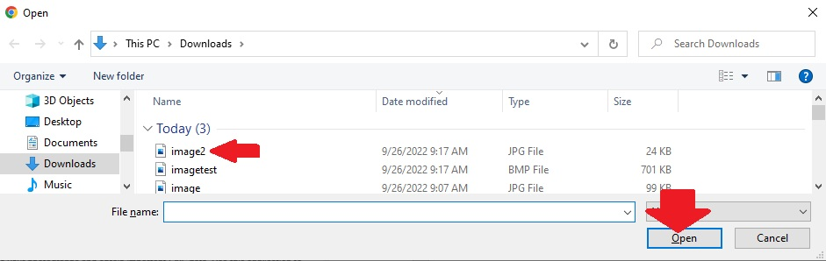

Figure Explorer

### **5.2 Results Page**

* Once a file has been uploaded, click on the submit button. This will bring you to the Data Pane on the Results page.

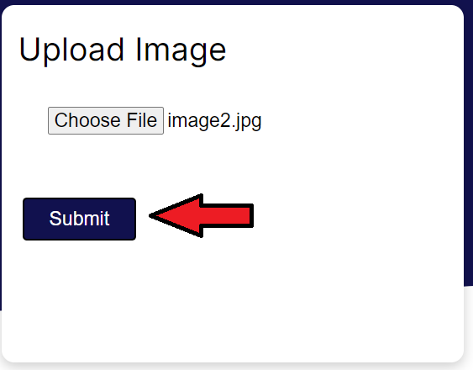

Figure Submit Button

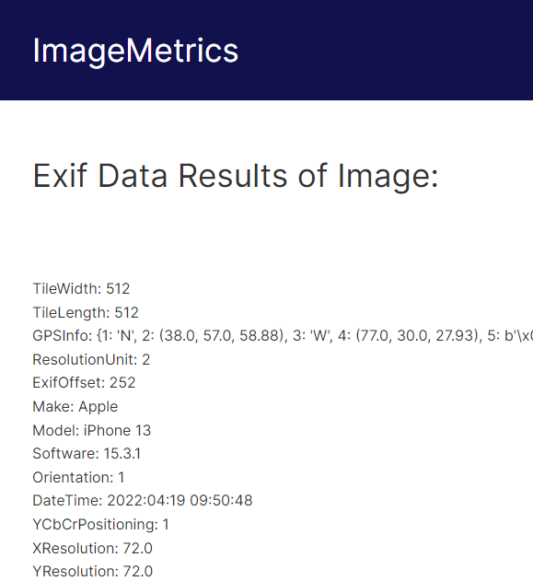

* Figure Data Pane
* Data pane
  + User is presented the exif data in the pane
* Export Button
  + User can export the data to a saved file
  + This button is located at the bottom of the page.

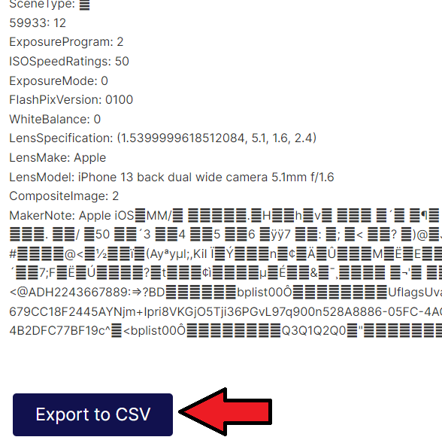

* Figure Data Pane 2
* About Button
  + User is taken to an “about” page to learn about the site and what it is capable of.
* Figure About Button

### **5.3 About Page**

* User is presented a guide to show what the site is capable of.
* Home button
  + 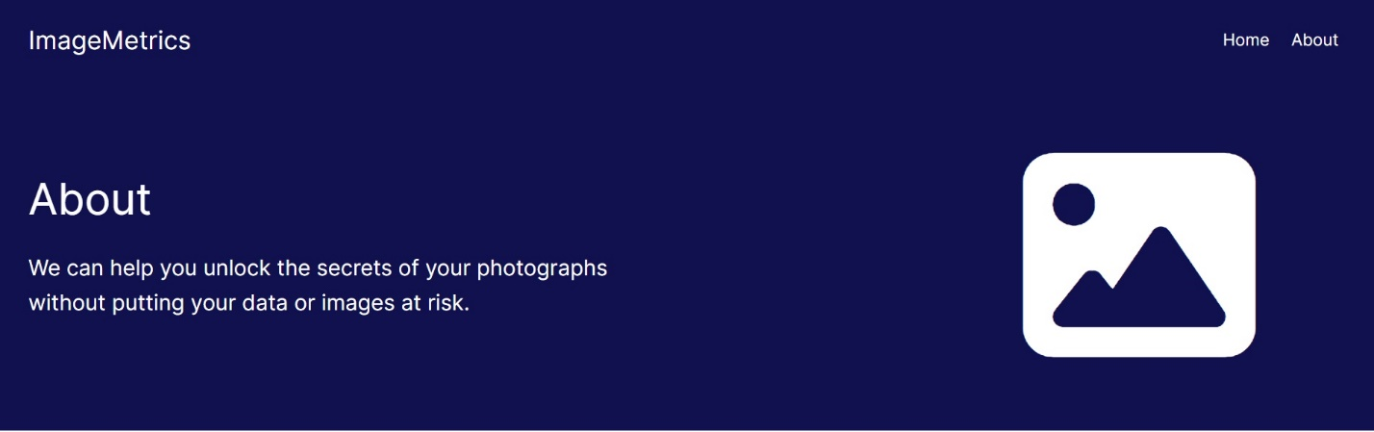Returns the user to the home page
* Figure About Page